# Gesture recognition

## Learning objectives

In this course, we mainly learn to implement gesture recognition functions using STM32F103RCT6 and gesture recognition module modules.

## Prepare before class

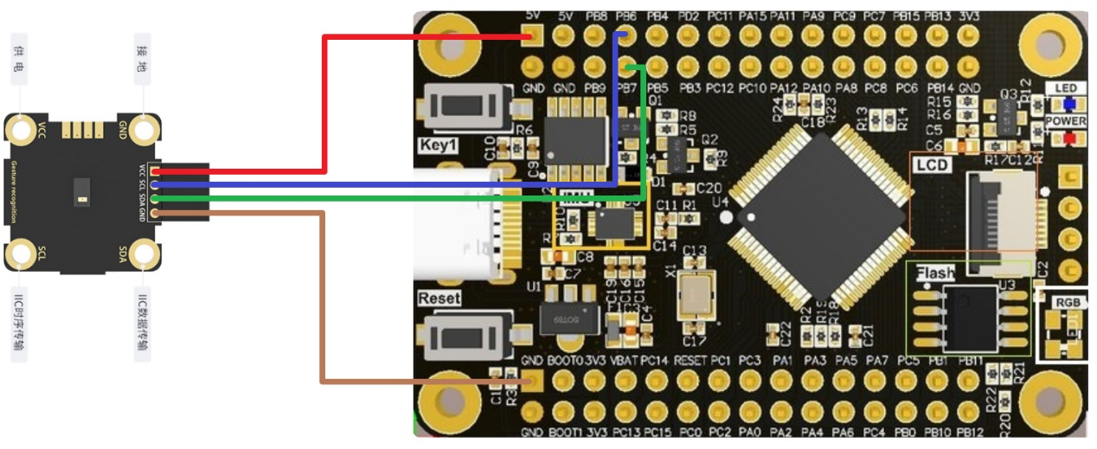

The gesture recognition module adopts I2C communication, and the SDA and SCL of the module are connected to the PB7 and PB6 pins of the STM32F103RCT6 board.

## Program

The I2C address of the module is 0x73, and the last bit needs to be reserved as a read and write bit, so it is shifted to the left.



Define initialization arrays, register arrays, gesture register addresses.

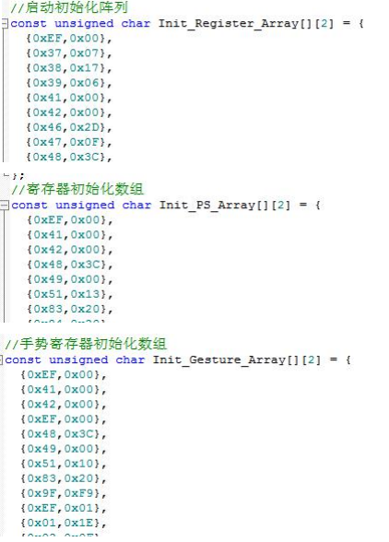

Initialize the gesture recognition module, return 1 for success and 0 for failure.

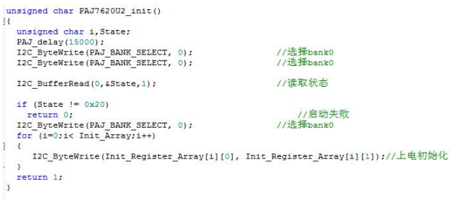

Gesture recognition register value writes.



By reading the value recognized by the gesture, and then judging it through the switch statement, and then printing out the corresponding gesture name by the serial port.

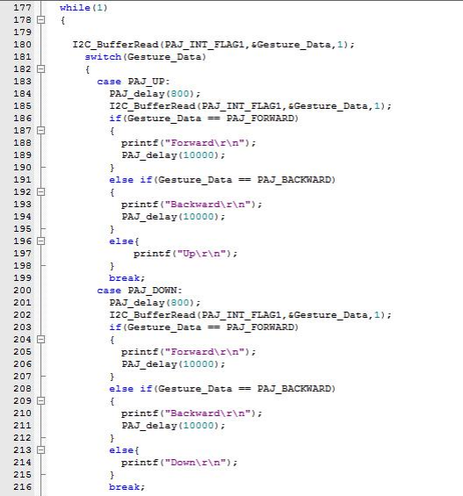

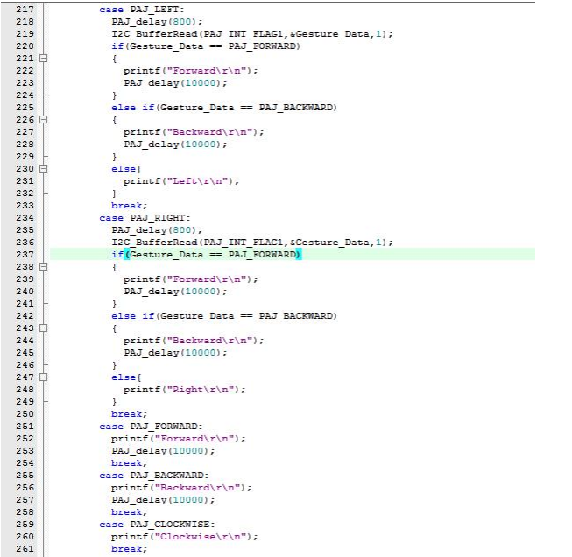

## Experimental phenomenon

After the program is downloaded, it will run it, and if the module is successfully initialized, it will print "Gesture Sensor OK", otherwise "Gesture Sensor Error" will be printed. If initialization fails, you can reset the program under STM32 to reinitialize. After successful initialization, the value of gesture recognition is judged, and different gestures will print out different action names through the serial port. Position the gesture recognition module upright, spread your palm to face the module, and swipe from left to right from the front of the module to print "Left". Swipe right to left from the front of the module to print "Right". Swipe from the front of the module from bottom to top to print "Up". Swipe down from the front of the module from top to bottom, and "Down" is printed. Approaching from the front of the module from back to front, "Forward" is printed. From the front of the module from front to back, "Backward" is printed. Clench your fist and point two or three fingers directly in front of the module, then make a short clockwise turn to print "Clockwise." Clench your fist and point two or three fingers directly in front of the module, then make a short counterclockwise turn to print "AntiClockwise." Wave your hand directly in front of the module for a while, and print "Wave".